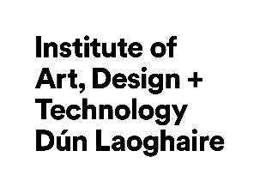


TU RISE Funded Elevate
Creation Bridge Postdoctoral Research Positions

EXPRESSION OF INTEREST APPLICATION FORM

Instructions for Applicants
Please consult the TU RISE Funded Elevate Creation Bridge Postdoctoral Research Positions Call Document before submitting your application. It is strongly advised that you are acquainted with the following sections before applying:

- Call Objectives;
- The Role of Elevate Creation Bridge Postdoctoral Researchers;
- Application Process;
- Guidance for Applicants;
- Funding;
- Eligibility Criteria;
- Review Process;
- Application Schedule;
- How to Apply.
Please email your completed application to elevate@iadt.ie by 12pm on 13 October 2025. Late applications will not be accepted.

APPLICANT
Name
Address:
Email Address:
ORCID ID:

PROJECT
Project Title:
Project Summary (max. 250 words):
Project Background (max. 1000 words):
Describe the background of the project and motivation to undertake it.
Project Objectives (max. 250 words):
Outline project objectives. It is advised that the objectives be SMART (Specific, Measurable, Achievable, Realistic, and Timely).
Project Work Plan and Gantt Chart (max. 1000 words for work plan and Gantt chart in a separate file):
Describe the project plan and design;
Divide the work plan into work packages (WPs) and describe the deliverables of each WP;
Provide Gantt chart detailed the timelines of the project plan (uploaded as a PDF in a separate file);

Statement of Proposal Alignment with the Elevate Programme Objectives (max. 500 words):
Describe how the project aligns with the Elevate objectives;
Outline the sustainability of the project outcomes and impacts.

Statement of Potential for the Project to Deliver Clear and Significant Societal, Cultural and Economic Impact (max. 1000 words):
Outline the multidisciplinary or interdisciplinary aspects of the project and describe how the project will deliver societal, cultural and economic impacts.

